**REPORT**

**Random Walk Experiment (Assignment 1)**

The aim of this assignment to derive relation for finding the distance *d* of a drunk man from the lamp post in no of steps *n* given that length *l* of each step is same.

**Terminologies:**

*d* - mean distance

*n* – No of Steps

*l* – Length of Steps

**Flow of logic :**

1. Assume the initial location of drunk man to be A(0,0).
2. Find the random points from point A in any random direction North, South, East and West by passing the no of steps *n* he move towards the lamp post, assuming the length *l* of each step to be constant.
3. By using the Eucledian Distance formula, find out the distance *d* between initial point and last point.
4. Since distance *d* is directly proportional to no of steps *n*, following values have been observed by increasing/decreasing the value of *n*.

**Observations :**

|  |  |
| --- | --- |
| *d* | *n* |
| 10.00107 | 100 |
| 13.1624 | 200 |
| 13.65842 | 300 |
| 18.82743 | 400 |
| 18.14686 | 500 |
| 24.08776 | 600 |
| 24.95524 | 700 |
| 24.01144 | 800 |
| 29.39426 | 900 |
| 29.21529 | 1000 |

Graph plotted based on above values :

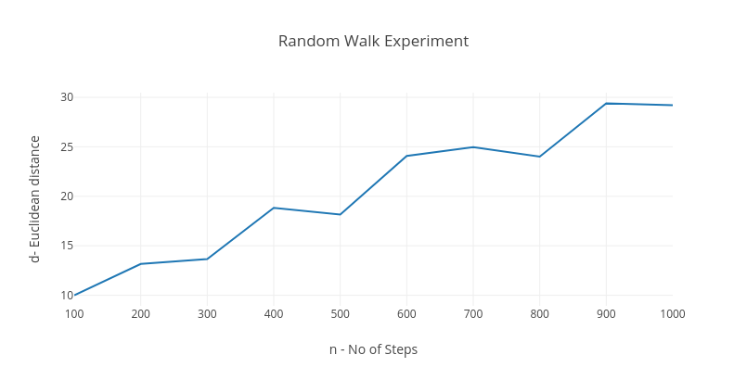

From the above graph, as the no of steps n is increasing ,d is observed to be approximately the root-mean-squared value of n.

Hence the relation obtained is :

*d = < Math.sqrt(n*l)*

where l is the length of each step. Please note that, d is generally less than or close to the square root of *n*, but rarerly matches square root of *n.*